EXPERIMENT : FLAME SENSOR Alert System Using DE0- Nano FPGA with Buzzer and LED Indicators

Objective:

To design and implement a flame detection system using Verilog HDL on the DE0-Nano FPGA board.
The system reads input from a flame sensor, and in case of flame detection, triggers a buzzer and LED indicators.
This project demonstrates real-time hazard detection using digital control logic and sensor interfacing.

Materials Required:

- DE0-Nano FPGA Development Board
- Flame Sensor (Digital Output)
- Active Buzzer Module
- Jumper Wires
- Intel Quartus Prime Lite Edition
- USB Blaster (for programming FPGA)
- PC or Laptop
- CP2102 USB-to-Serial Converter (optional, for UART debugging)

Theory:

The flame sensor is an infrared sensor module that detects fire or IR light from flames. It gives a digital LOW (0) signal when a flame is detected, and HIGH (1) when not.
In this project:
- If the sensor detects flame → Buzzer ON + Both LEDs blink
- If no flame is present → Only one LED blinks, and buzzer remains OFF
The logic is implemented using Verilog and synthesized on the DE0-Nano FPGA board.

Logic Expressions / Functionality:

Sensor Output | LED Output | Buzzer
1 (No flame) | led_output= 2'b01 (LED0 ON) | OFF
0 (Flame detected) | led_output= 2'b11 (LED0 & LED1 ON) | ON

Experimental Procedure:

Hardware Connections:

Flame Sensor VCC → JP1 pin 11 (3.3V)
Flame Sensor GND → JP1 pin 12 (GND)
Flame Sensor OUT → JP1 pin 2 (GPIO_0[0])
Buzzer VCC → JP2 pin 2 (GPIO_1[0])
Buzzer GND → JP2 pin 12 (GND)

FPGA Pin Assignments:

Signal Name | Direction | Pin | Description
flame_do | Input | PIN_D3 | Flame sensor digital output
clk | Input | PIN_R8 | Clock signal
buzzer | Output | PIN_F13 | Controls buzzer
led_output[0] | Output | PIN_A15 | LED0 indicator
led_output[1] | Output | PIN_A13 | LED1 indicator

Pin Planner Screenshot:

The image below shows the pin assignments done in Intel Quartus Prime using the Pin Planner tool for the flame sensor, buzzer, and LEDs.

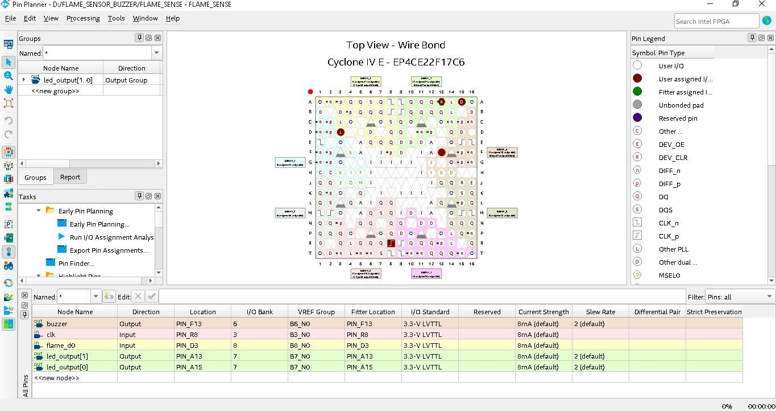

Figure 1: Screenshot of Pin Planner in Quartus showing assigned FPGA pins.

Verilog Code :

Main Module :

module flame_sensor (
input clk,
input flame_d0, // Input from flame sensor D0
output reg [1:0] leds, // Output to two LEDs
output reg buzzer_out // Output to buzzer
);

reg [23:0] counter = 0; // For blinking delay
reg blink = 0;

always @(posedge clk) begin
// Simple counter for blinking (~half-second blink on 50 MHz clock)
counter <= counter + 1;
if (counter == 24'd5000000) begin
blink <= ~blink;
counter <= 0;
end

if (flame_d0 == 0) begin
// Flame Detected
leds[0] <= blink;
leds[1] <= blink;
buzzer_out <= 1'b1; // Buzzer ON
end else begin
// No Flame
leds[0] <= blink;
leds[1] <= 1'b0;
buzzer_out <= 1'b0; // Buzzer OFF
end
end

endmodule

Top Module:

module top_flame_sensor (
input clk, // 50 MHz system clock
input flame_d0, // From flame sensor D0 (GPIO_00)
output [1:0] led_output, // Connects to LEDR[1:0]
output buzzer // Connect this to GPIO pin for buzzer
);

flame_sensor u_flame_sensor (
.clk(clk),
.flame_d0(flame_d0),
.leds(led_output),
.buzzer_out(buzzer)
);

endmodule

Project Setup Photo:

The following image shows the actual hardware setup of the flame sensor with the DE0-Nano FPGA board and buzzer connected as per the described connections.

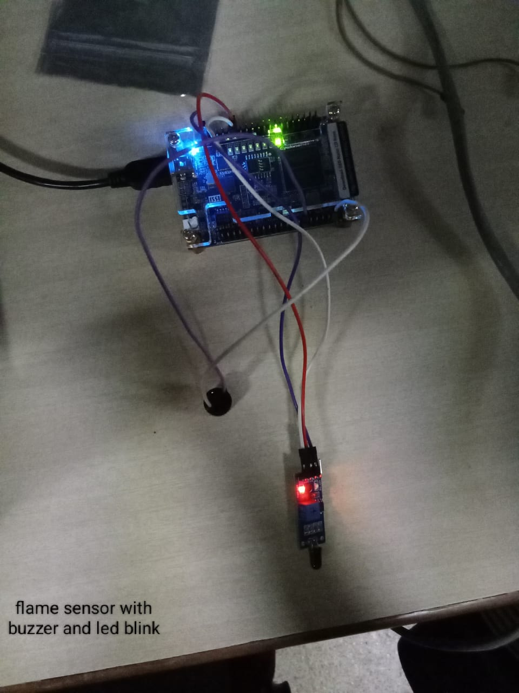
Figure 2: Working prototype showing flame sensor, LEDs, and buzzer on DE0-Nano.

Expected Output:

- No Flame:
LED0 glows
Buzzer OFF

- Flame Detected:
LED0 and LED1 both glow
Buzzer ON

Applications:

- Fire and flame detection in embedded systems
- Industrial safety and monitoring
- Early warning systems in hazardous environments
- Educational labs for real-time sensor interfacing

Conclusion:

The flame detection system was successfully implemented using Verilog and tested on the DE0-Nano FPGA board.
It effectively detects flame presence and triggers visual (LED) and auditory (buzzer) alerts.
This project provided practical experience in interfacing sensors with FPGA and designing real-time digital logic systems.

